**Exercise 1: Control Structures**

**Code:**

**Applying 1% Interest Discount for Customers Above 60:**

BEGIN

FOR rec IN (SELECT c.CustomerID, c.Name, l.LoanID, l.InterestRate, c.DOB

FROM Customers c

JOIN Loans l ON c.CustomerID = l.CustomerID)

LOOP

IF MONTHS_BETWEEN(SYSDATE, rec.DOB) / 12 > 60 THEN

UPDATE Loans

SET InterestRate = InterestRate - 1

WHERE LoanID = rec.LoanID;

DBMS_OUTPUT.PUT_LINE('Applied discount to ' || rec.Name || '''s loan.');

END IF;

END LOOP;

COMMIT;

END;

/

**Output:**

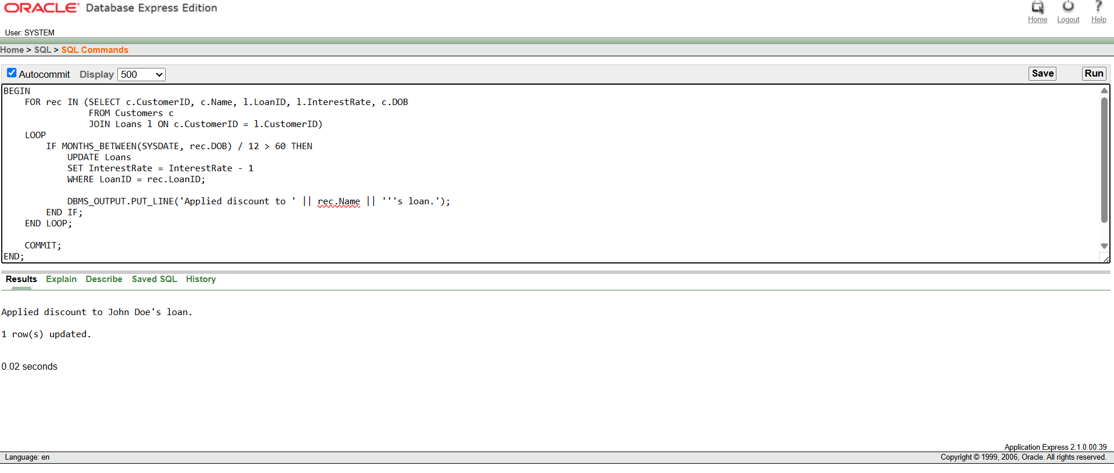

Promoting Customers with Balance > $10,000 to VIP:

**Code:**

**ALTER TABLE Customers ADD IsVIP VARCHAR2(5);**

**Output:**

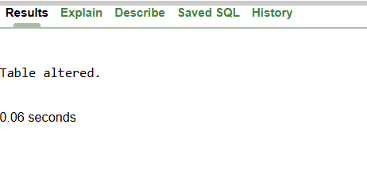

**Code:**

BEGIN

FOR rec IN (SELECT CustomerID, Name, Balance FROM Customers)

LOOP

IF rec.Balance > 10000 THEN

UPDATE Customers

SET IsVIP = 'TRUE'

WHERE CustomerID = rec.CustomerID;

DBMS_OUTPUT.PUT_LINE('Promoted ' || rec.Name || ' to VIP.');

END IF;

END LOOP;

COMMIT;

END;

/

**Output:**

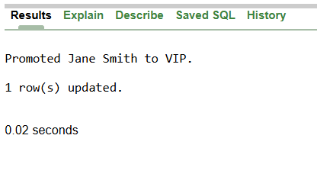

**Reminding Customers with Loans Due in 30 Days**

**Code:**

BEGIN

FOR rec IN (

SELECT c.Name, l.LoanID, l.EndDate

FROM Loans l

JOIN Customers c ON l.CustomerID = c.CustomerID

WHERE l.EndDate BETWEEN SYSDATE AND SYSDATE + 30

)

LOOP

DBMS_OUTPUT.PUT_LINE('Reminder: ' || rec.Name || ', your loan (ID: ' || rec.LoanID || ') is due on ' || TO_CHAR(rec.EndDate, 'DD-MON-YYYY'));

END LOOP;

END;

/

**Output:**

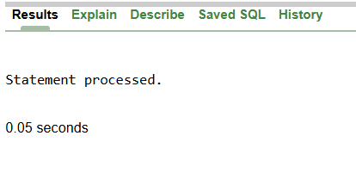

**Exercise-2: Error Handling**

**Safe Fund Transfer Between Accounts**

**Code:**

CREATE OR REPLACE PROCEDURE SafeTransferFunds (

p_from_account_id IN NUMBER,

p_to_account_id IN NUMBER,

p_amount IN NUMBER

)

IS

v_from_balance NUMBER;

BEGIN

-- Check balance of source account

SELECT Balance INTO v_from_balance FROM Accounts WHERE AccountID = p_from_account_id;

IF v_from_balance < p_amount THEN

RAISE_APPLICATION_ERROR(-20001, 'Insufficient funds in the source account.');

END IF;

-- Deduct from source account

UPDATE Accounts

SET Balance = Balance - p_amount

WHERE AccountID = p_from_account_id;

-- Add to destination account

UPDATE Accounts

SET Balance = Balance + p_amount

WHERE AccountID = p_to_account_id;

COMMIT;

DBMS_OUTPUT.PUT_LINE('Transfer successful.');

EXCEPTION

WHEN OTHERS THEN

ROLLBACK;

DBMS_OUTPUT.PUT_LINE('Error: ' || SQLERRM);

END;

/

BEGIN

SafeTransferFunds(1, 2, 500);

END;

/

**Output:**

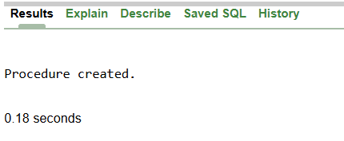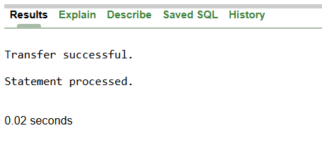

**Update Employee Salary with Error Logging**

**Code:**

CREATE OR REPLACE PROCEDURE UpdateSalary (

p_emp_id IN NUMBER,

p_percent IN NUMBER

)

IS

BEGIN

UPDATE Employees

SET Salary = Salary + (Salary * p_percent / 100)

WHERE EmployeeID = p_emp_id;

IF SQL%ROWCOUNT = 0 THEN

RAISE_APPLICATION_ERROR(-20002, 'Employee not found.');

END IF;

COMMIT;

DBMS_OUTPUT.PUT_LINE('Salary updated.');

EXCEPTION

WHEN OTHERS THEN

ROLLBACK;

DBMS_OUTPUT.PUT_LINE('Error updating salary: ' || SQLERRM);

END;

/

BEGIN

UpdateSalary(2, 10);

END;

/

**Output:**

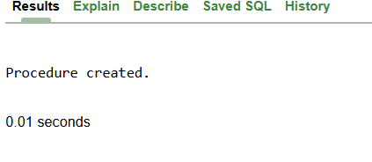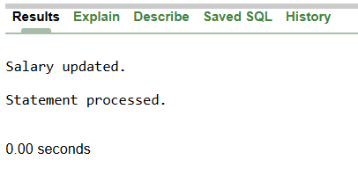

**Adding New Customer with Duplicate ID Handling:**

**Code:**

CREATE OR REPLACE PROCEDURE AddNewCustomer (

p_id IN NUMBER,

p_name IN VARCHAR2,

p_dob IN DATE,

p_balance IN NUMBER

)

IS

BEGIN

INSERT INTO Customers (CustomerID, Name, DOB, Balance, LastModified)

VALUES (p_id, p_name, p_dob, p_balance, SYSDATE);

COMMIT;

DBMS_OUTPUT.PUT_LINE('Customer added successfully.');

EXCEPTION

WHEN DUP_VAL_ON_INDEX THEN

DBMS_OUTPUT.PUT_LINE('Error: Customer ID already exists.');

WHEN OTHERS THEN

DBMS_OUTPUT.PUT_LINE('Unexpected error: ' || SQLERRM);

END;

/

BEGIN

AddNewCustomer(3, 'Charlie Chaplin', TO_DATE('1970-01-01', 'YYYY-MM-DD'), 3000);

END;

/

**Output:**

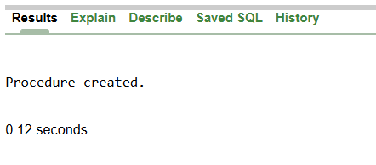 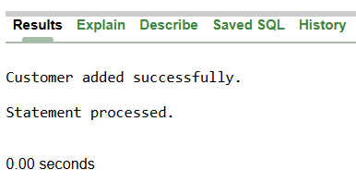

**Exercise-3: Stored Procedures**

**Processing Monthly Interest for Savings Accounts**

**Code:**

CREATE OR REPLACE PROCEDURE ProcessMonthlyInterest

IS

BEGIN

FOR rec IN (SELECT AccountID, Balance FROM Accounts WHERE AccountType = 'Savings') LOOP

UPDATE Accounts

SET Balance = Balance + (rec.Balance * 0.01)

WHERE AccountID = rec.AccountID;

DBMS_OUTPUT.PUT_LINE('Interest applied to Account ID ' || rec.AccountID);

END LOOP;

COMMIT;

END;

/

**Output:**

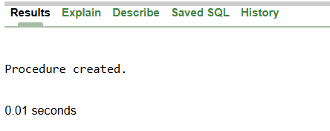

**Bonus Scheme Based on Department:**

**Code:**

CREATE OR REPLACE PROCEDURE UpdateEmployeeBonus (

p_department IN VARCHAR2,

p_bonus_percent IN NUMBER

)

IS

BEGIN

UPDATE Employees

SET Salary = Salary + (Salary * p_bonus_percent / 100)

WHERE Department = p_department;

DBMS_OUTPUT.PUT_LINE(SQL%ROWCOUNT || ' employee(s) updated with bonus.');

COMMIT;

END;

/

BEGIN

UpdateEmployeeBonus('IT', 15);

END;

/

**Output:**

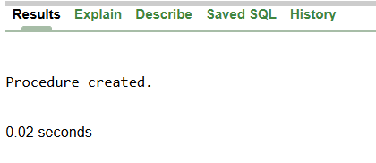 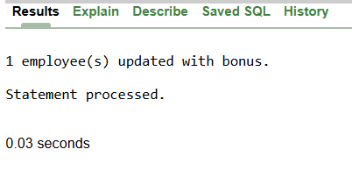

**Transfer Funds Between Accounts:**

**Code:**

CREATE OR REPLACE PROCEDURE TransferFunds (

p_from_account IN NUMBER,

p_to_account IN NUMBER,

p_amount IN NUMBER

)

IS

v_balance NUMBER;

BEGIN

SELECT Balance INTO v_balance FROM Accounts WHERE AccountID = p_from_account;

IF v_balance < p_amount THEN

RAISE_APPLICATION_ERROR(-20003, 'Insufficient balance.');

END IF;

UPDATE Accounts

SET Balance = Balance - p_amount

WHERE AccountID = p_from_account;

UPDATE Accounts

SET Balance = Balance + p_amount

WHERE AccountID = p_to_account;

COMMIT;

DBMS_OUTPUT.PUT_LINE('Transfer complete.');

EXCEPTION

WHEN OTHERS THEN

ROLLBACK;

DBMS_OUTPUT.PUT_LINE('Error: ' || SQLERRM);

END;

/

BEGIN

TransferFunds(1, 2, 300);

END;

/

**Output:**

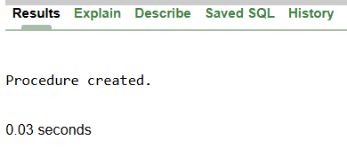 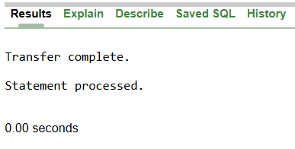

**Exercise-4: Functions**

**Calculate Age from DOB**

**Code:**

CREATE OR REPLACE FUNCTION CalculateAge (

p_dob IN DATE

) RETURN NUMBER

IS

v_age NUMBER;

BEGIN

v_age := FLOOR(MONTHS_BETWEEN(SYSDATE, p_dob) / 12);

RETURN v_age;

END;

/

BEGIN

DBMS_OUTPUT.PUT_LINE('Age: ' || CalculateAge(TO_DATE('1990-07-20', 'YYYY-MM-DD')));

END;

/

**Output:**

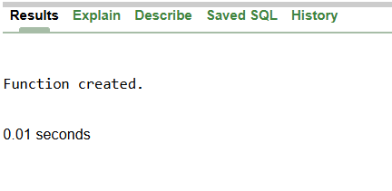 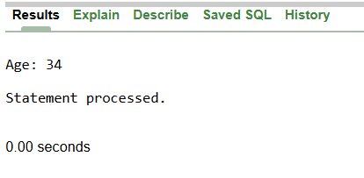

**Calculate Monthly Installment:**

Formula used:  
EMI = P × r × (1 + r)^n / ((1 + r)^n - 1)  
Where:

P = loan amount

r = monthly interest rate

n = total number of months

**Code:**

CREATE OR REPLACE FUNCTION CalculateMonthlyInstallment (

p_loan_amount IN NUMBER,

p_annual_rate IN NUMBER,

p_duration_years IN NUMBER

) RETURN NUMBER

IS

v_monthly_rate NUMBER := p_annual_rate / 12 / 100;

v_months NUMBER := p_duration_years * 12;

v_emi NUMBER;

BEGIN

v_emi := (p_loan_amount * v_monthly_rate * POWER(1 + v_monthly_rate, v_months)) /

(POWER(1 + v_monthly_rate, v_months) - 1);

RETURN ROUND(v_emi, 2);

END;

/

BEGIN

DBMS_OUTPUT.PUT_LINE('EMI: ' || CalculateMonthlyInstallment(10000, 6, 5));

END;

/

**Output:**

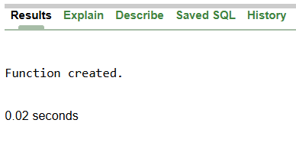 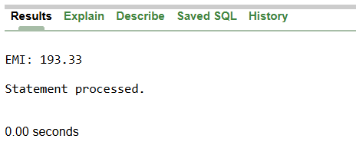

**Check Sufficient Balance:**

**Code:**

CREATE OR REPLACE FUNCTION HasSufficientBalance (

p_account_id IN NUMBER,

p_amount IN NUMBER

) RETURN BOOLEAN

IS

v_balance NUMBER;

BEGIN

SELECT Balance INTO v_balance FROM Accounts WHERE AccountID = p_account_id;

RETURN v_balance >= p_amount;

EXCEPTION

WHEN NO_DATA_FOUND THEN

RETURN FALSE;

END;

/

DECLARE

result BOOLEAN;

BEGIN

result := HasSufficientBalance(1, 500);

IF result THEN

DBMS_OUTPUT.PUT_LINE('Balance is sufficient.');

ELSE

DBMS_OUTPUT.PUT_LINE('Balance is NOT sufficient.');

END IF;

END;

/

**Output:**

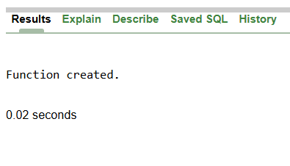 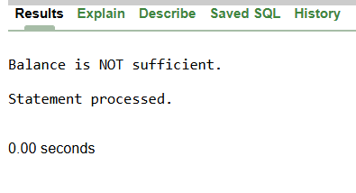

**Exercise-5: Triggers**

**Auto-update LastModified on Customer Record Update**

**Code:**

CREATE OR REPLACE TRIGGER UpdateCustomerLastModified

BEFORE UPDATE ON Customers

FOR EACH ROW

BEGIN

:NEW.LastModified := SYSDATE;

END;

/

**Output:**

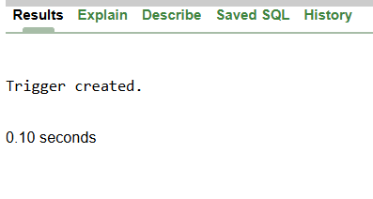

**Audit Log for Transactions:**

**Code:**

CREATE TABLE AuditLog (

LogID NUMBER PRIMARY KEY,

AccountID NUMBER,

Amount NUMBER,

TransactionType VARCHAR2(10),

LoggedAt DATE

);

CREATE SEQUENCE AuditLogSeq

START WITH 1

INCREMENT BY 1;

CREATE OR REPLACE TRIGGER LogTransaction

BEFORE INSERT ON Transactions

FOR EACH ROW

BEGIN

INSERT INTO AuditLog (LogID, AccountID, Amount, TransactionType, LoggedAt)

VALUES (

AuditLogSeq.NEXTVAL,

:NEW.AccountID,

:NEW.Amount,

:NEW.TransactionType,

SYSDATE

);

END;

/

**Output:**

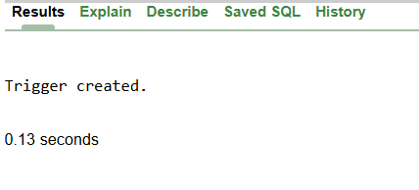

**Enforce Transaction Rules:**

**Code:**

CREATE OR REPLACE TRIGGER CheckTransactionRules

BEFORE INSERT ON Transactions

FOR EACH ROW

DECLARE

v_balance NUMBER;

BEGIN

SELECT Balance INTO v_balance FROM Accounts WHERE AccountID = :NEW.AccountID;

IF :NEW.TransactionType = 'Withdrawal' AND :NEW.Amount > v_balance THEN

RAISE_APPLICATION_ERROR(-20004, 'Withdrawal exceeds available balance.');

ELSIF :NEW.TransactionType = 'Deposit' AND :NEW.Amount <= 0 THEN

RAISE_APPLICATION_ERROR(-20005, 'Deposit amount must be positive.');

END IF;

END;

/

**Output:**

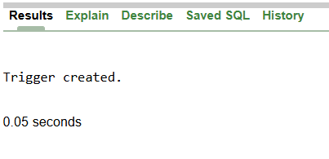

**Exercise-6: Cursors**

**Generate Monthly Statements**

**Code:**

DECLARE

CURSOR txn_cursor IS

SELECT c.Name, a.AccountID, t.TransactionDate, t.Amount, t.TransactionType

FROM Customers c

JOIN Accounts a ON c.CustomerID = a.CustomerID

JOIN Transactions t ON a.AccountID = t.AccountID

WHERE TO_CHAR(t.TransactionDate, 'MMYYYY') = TO_CHAR(SYSDATE, 'MMYYYY');

v_name Customers.Name%TYPE;

v_acc_id Accounts.AccountID%TYPE;

v_date DATE;

v_amount NUMBER;

v_type VARCHAR2(10);

BEGIN

OPEN txn_cursor;

LOOP

FETCH txn_cursor INTO v_name, v_acc_id, v_date, v_amount, v_type;

EXIT WHEN txn_cursor%NOTFOUND;

DBMS_OUTPUT.PUT_LINE('Customer: ' || v_name ||

' | Account ID: ' || v_acc_id ||

' | Date: ' || TO_CHAR(v_date, 'DD-MON-YYYY') ||

' | ' || v_type || ': ' || v_amount);

END LOOP;

CLOSE txn_cursor;

END;

/

**Output:**

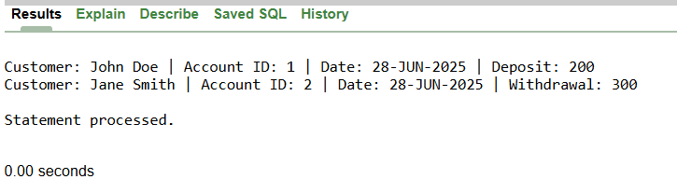

**Apply Annual Fee:**

**Code:**

DECLARE

CURSOR acc_cursor IS

SELECT AccountID, Balance FROM Accounts;

v_id Accounts.AccountID%TYPE;

v_bal Accounts.Balance%TYPE;

v_fee NUMBER := 100; -- fixed annual fee

BEGIN

OPEN acc_cursor;

LOOP

FETCH acc_cursor INTO v_id, v_bal;

EXIT WHEN acc_cursor%NOTFOUND;

UPDATE Accounts

SET Balance = Balance - v_fee

WHERE AccountID = v_id;

DBMS_OUTPUT.PUT_LINE('Annual fee of ' || v_fee || ' deducted from Account ID ' || v_id);

END LOOP;

CLOSE acc_cursor;

COMMIT;

END;

/

**Output:**

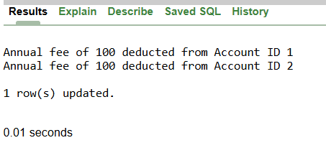

**Update Loan Interest Rates(Policy Change):**

**Code:**

DECLARE

CURSOR loan_cursor IS

SELECT LoanID, InterestRate FROM Loans;

v_loan_id Loans.LoanID%TYPE;

v_rate Loans.InterestRate%TYPE;

BEGIN

OPEN loan_cursor;

LOOP

FETCH loan_cursor INTO v_loan_id, v_rate;

EXIT WHEN loan_cursor%NOTFOUND;

UPDATE Loans

SET InterestRate = v_rate + 0.5

WHERE LoanID = v_loan_id;

DBMS_OUTPUT.PUT_LINE('Updated interest rate for Loan ID ' || v_loan_id);

END LOOP;

CLOSE loan_cursor;

COMMIT;

END;

/

**Output:**

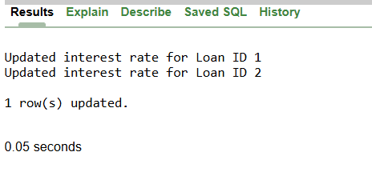

**Exercise-7: Packages**

**Package for Customer Management**

**Code:**

CREATE OR REPLACE PACKAGE CustomerManagement AS

PROCEDURE AddCustomer(p_id NUMBER, p_name VARCHAR2, p_dob DATE, p_balance NUMBER);

PROCEDURE UpdateCustomer(p_id NUMBER, p_name VARCHAR2, p_balance NUMBER);

FUNCTION GetCustomerBalance(p_id NUMBER) RETURN NUMBER;

END CustomerManagement;

/

CREATE OR REPLACE PACKAGE BODY CustomerManagement AS

PROCEDURE AddCustomer(p_id NUMBER, p_name VARCHAR2, p_dob DATE, p_balance NUMBER) IS

BEGIN

INSERT INTO Customers (CustomerID, Name, DOB, Balance, LastModified)

VALUES (p_id, p_name, p_dob, p_balance, SYSDATE);

END;

PROCEDURE UpdateCustomer(p_id NUMBER, p_name VARCHAR2, p_balance NUMBER) IS

BEGIN

UPDATE Customers

SET Name = p_name, Balance = p_balance, LastModified = SYSDATE

WHERE CustomerID = p_id;

END;

FUNCTION GetCustomerBalance(p_id NUMBER) RETURN NUMBER IS

v_balance NUMBER;

BEGIN

SELECT Balance INTO v_balance FROM Customers WHERE CustomerID = p_id;

RETURN v_balance;

END;

END CustomerManagement;

/

BEGIN

CustomerManagement.AddCustomer(4, 'Arnold Watt', TO_DATE('1999-02-18', 'YYYY-MM-DD'), 6000);

DBMS_OUTPUT.PUT_LINE('Balance: ' || CustomerManagement.GetCustomerBalance(4));

END;

/

**Output:**

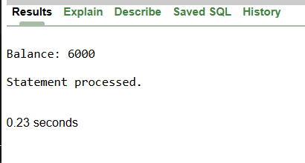

**Employee Management Package**

**Code:**

CREATE OR REPLACE PACKAGE EmployeeManagement AS

PROCEDURE HireEmployee(p_id NUMBER, p_name VARCHAR2, p_position VARCHAR2, p_salary NUMBER, p_dept VARCHAR2, p_hire_date DATE);

PROCEDURE UpdateEmployee(p_id NUMBER, p_position VARCHAR2, p_salary NUMBER);

FUNCTION GetAnnualSalary(p_id NUMBER) RETURN NUMBER;

END EmployeeManagement;

/

CREATE OR REPLACE PACKAGE BODY EmployeeManagement AS

PROCEDURE HireEmployee(p_id NUMBER, p_name VARCHAR2, p_position VARCHAR2, p_salary NUMBER, p_dept VARCHAR2, p_hire_date DATE) IS

BEGIN

INSERT INTO Employees (EmployeeID, Name, Position, Salary, Department, HireDate)

VALUES (p_id, p_name, p_position, p_salary, p_dept, p_hire_date);

END;

PROCEDURE UpdateEmployee(p_id NUMBER, p_position VARCHAR2, p_salary NUMBER) IS

BEGIN

UPDATE Employees

SET Position = p_position, Salary = p_salary

WHERE EmployeeID = p_id;

END;

FUNCTION GetAnnualSalary(p_id NUMBER) RETURN NUMBER IS

v_salary NUMBER;

BEGIN

SELECT Salary INTO v_salary FROM Employees WHERE EmployeeID = p_id;

RETURN v_salary * 12;

END;

END EmployeeManagement;

/

BEGIN

DBMS_OUTPUT.PUT_LINE('Annual Salary: ' || EmployeeManagement.GetAnnualSalary(2));

END;

/

**Output:**

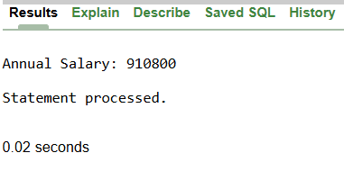

**Account Operations Package**

**Code:**

CREATE OR REPLACE PACKAGE AccountOperations AS

PROCEDURE OpenAccount(p_id NUMBER, p_customer_id NUMBER, p_type VARCHAR2, p_balance NUMBER);

PROCEDURE CloseAccount(p_id NUMBER);

FUNCTION GetTotalCustomerBalance(p_customer_id NUMBER) RETURN NUMBER;

END AccountOperations;

/

CREATE OR REPLACE PACKAGE BODY AccountOperations AS

PROCEDURE OpenAccount(p_id NUMBER, p_customer_id NUMBER, p_type VARCHAR2, p_balance NUMBER) IS

BEGIN

INSERT INTO Accounts (AccountID, CustomerID, AccountType, Balance, LastModified)

VALUES (p_id, p_customer_id, p_type, p_balance, SYSDATE);

END;

PROCEDURE CloseAccount(p_id NUMBER) IS

BEGIN

DELETE FROM Accounts WHERE AccountID = p_id;

END;

FUNCTION GetTotalCustomerBalance(p_customer_id NUMBER) RETURN NUMBER IS

v_total NUMBER;

BEGIN

SELECT SUM(Balance) INTO v_total FROM Accounts WHERE CustomerID = p_customer_id;

RETURN v_total;

END;

END AccountOperations;

/

BEGIN

DBMS_OUTPUT.PUT_LINE('Total Balance: ' || AccountOperations.GetTotalCustomerBalance(1));

END;

/

**Output:**

